**Single Responsibility Principle**

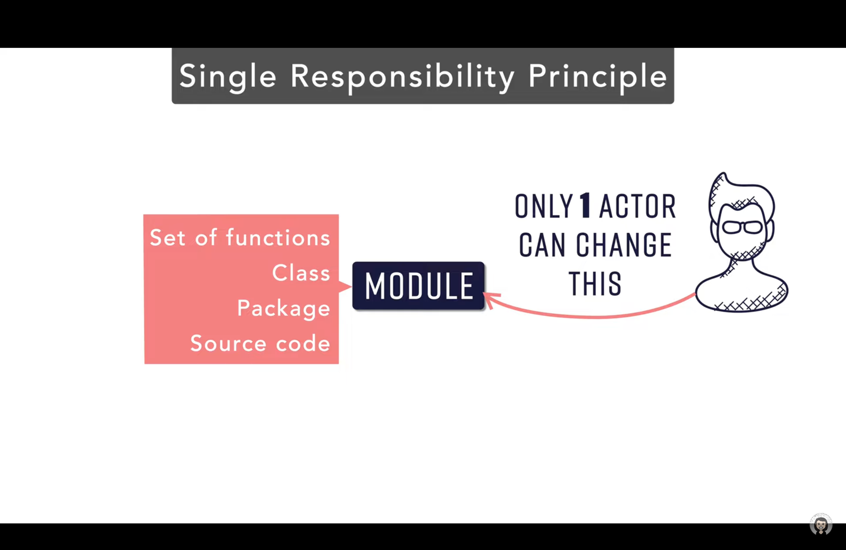

* One Module be it a Class, set of functions, Package or Source Code, can only be changed by one actor.
* Example:

* There is an Employee class which has 3 methods –
  + calculateSalary() which is used by CFO.
  + calculateHours which is used by HR.
  + saveEmpData() which is used by Technical team.

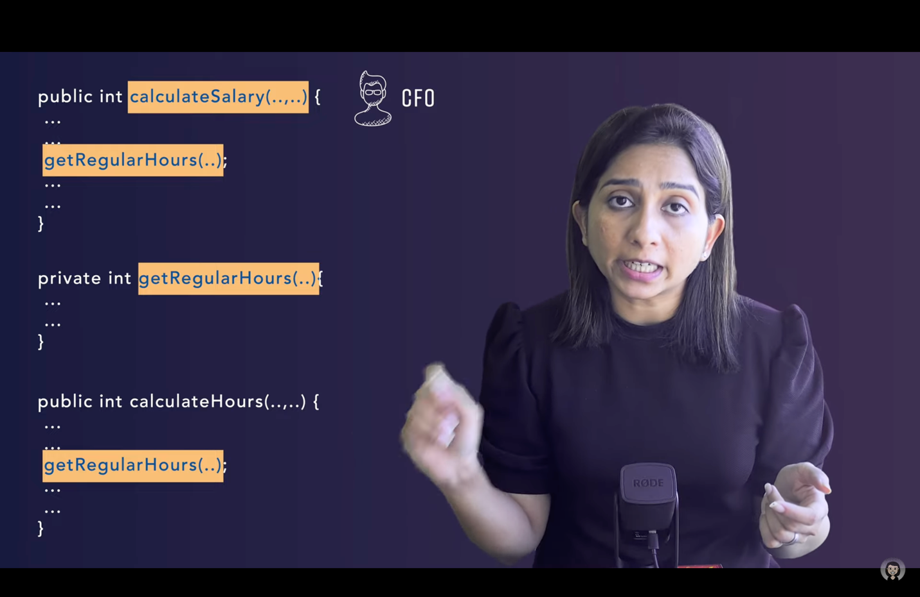

* Let’s say CFO required to make some change in the CalculateSalary() method, which impacted the getRegularHours() method to be changed also.
* This lead to an impact in the calculateHours() method functionality used by HR.
* This caused a System failure.
* This is what leads to break in the Single Responsibility Principle.

* The solution to this problem is to break the classes or decomposing one class into multiple classes.
* Now this system follows a Single Responsibility Principle class.

Note: Single Responsibility Principle does not mean that there should be only one public method in a class. It means that a module can only be accessed by a certain actor.